Last Wednesday, January 12, the BISB Bulldogs took down Dexter Southfield in a hard-fought , defense-heavy, game with a final score of 36-32. This was BISB’s first win of the season. The stands were filled with students and parents, with many cheering loudly for BISB.

BISB’s roster was depleted with many players out due to COVID-19 protocols and other factors, including team captain Michael Sherris, point guard Aria Khatib-Shahidi, forward Daniel Banar, guard Diego Duarte, and others. The team was only left with only five players ready to play the game, which is the bare minimum for a basketball team to be eligible to play a game. As a result, BISB had to call upon the help of three middle schoolers for the game at Dexter. They included: Justin, Backham, and Benjie.

The game was low-scoring throughout, with both teams playing strong defense. BISB’s offense was limited as they did not have their usual personnel. BISB, as they did in the first game, got off to a hot start. Center Vikrant Sabharwal scored the first 7 points of the game, including a three-pointer which prompted Dexter to call timeout. Dexter responded shortly after, and the two teams continued going back and forth for the remainder of the half. At halftime, BISB had a one point lead, 17-16.

The middle schoolers provided a huge spark for BISB in the second half. In the third quarter, Justin hit two 3 pointers, and Beckham hit one, giving BISB a big lead. The defense suffocated Dexter for the majority of the third quarter, as the Bulldogs forced numerous turnovers, some of which they were able to turn into points on the other end. The strong defense only allowed Dexter to score 2 baskets in the entire third quarter! The collective offensive and defense efforts enabled BISB to take a strong 10 point lead, with a score of 30-20, heading into the fourth quarter.

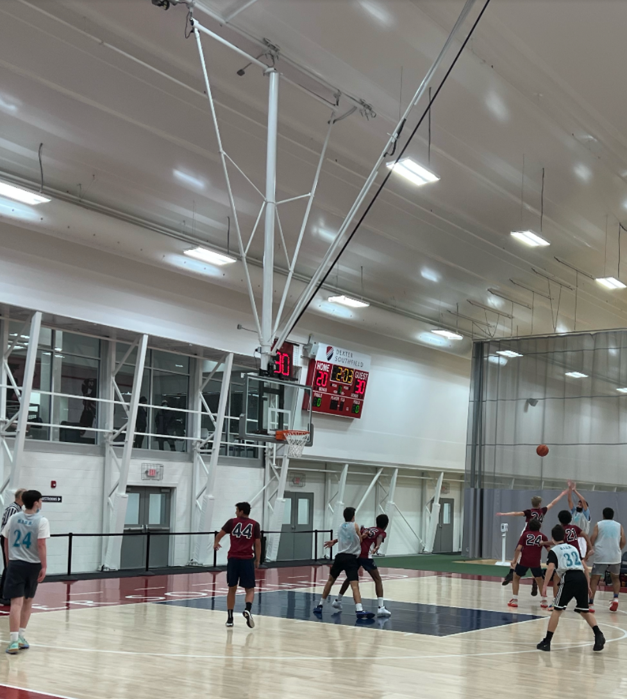

*Beckham takes a 3 point shot towards the end of the third quarter amid BISB’s big run to take their largest lead of the game.*

In the fourth quarter, Dexter came storming back, narrowing the deficit, and taking advantage of missed opportunities by BISB. They cut the lead to 4 with 1 minute to play in the game. However, BISB was able to hold off Dexter in the intense final minutes, to come away victorious.

The two teams will have a rematch soon as the Bulldogs will play at Dexter again later this season, on February 16th, at 4:15 pm.

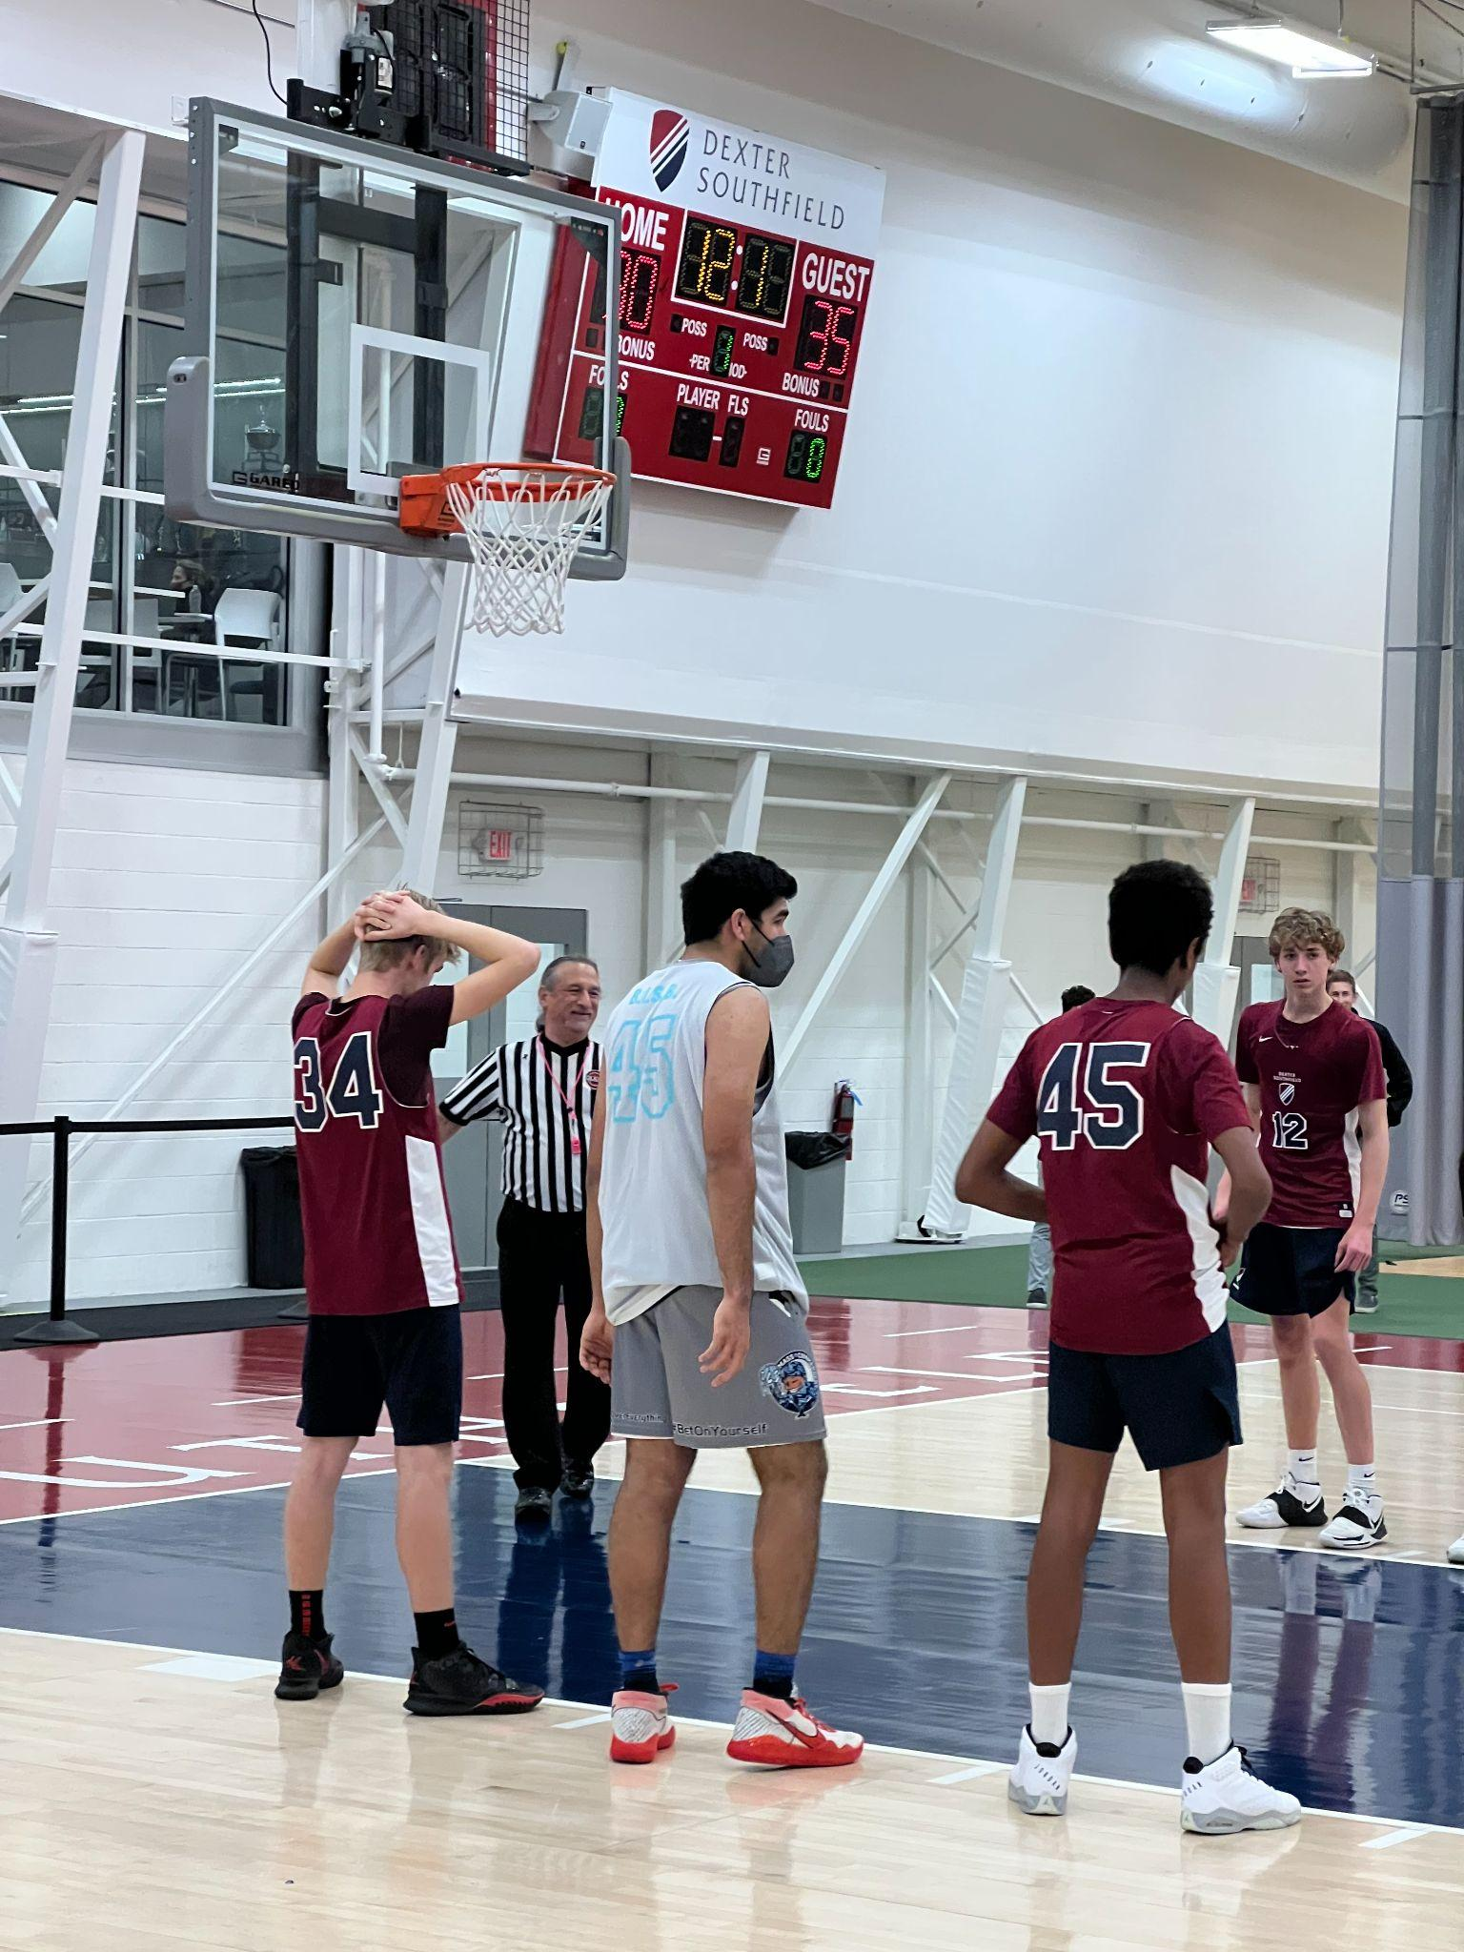

*Dexter shoots free throws, down by 5 to BISB, with only 12 seconds remaining in the game.*

BISB’s Coach Mike Carucci was very proud of the win, what he called a “a not pretty but grind-it-out win.” For him and the rest of the team, the way that the three middle schoolers came into this game against much bigger high schoolers, and provided a boost to help BISB win, will never be forgotten.

Coming up for the Bulldogs is the big rivalry game against ISB. The game will be played in the BISB gym on Monday, January 24, at 5:15 pm. Getting a win over their archrivals would be huge for the Bulldogs and only further their winning trajectory this season.

